QA Engineer Intern_Assignment Round

Assignment By:

Prashant Kumar

rahulprashant2001@gmail.com

**Assignment**

<https://samples.openweathermap.org/data/2.5/forecast/hourly?q=London,us&appid=b6907d289e10d714a6e88b30761fae22>

The above API is the REST GET API

Which gives you the response in JSON format and hourly weather forecast of London Location

I want you to write a program to get the option from the user and print the result based on the above API.

1. Get weather

2. Get Wind Speed

3. Get Pressure

0. Exit

If the user **press 1**, Prompt the user for the date then print the **temp of the input date**.

If the user **press 2**, Prompt the user for the date then print the **wind.speed of the input date**.

If the user **press 3**, Prompt the user for the date then print the **pressure of the input date**.

If the user **press 0**, **Terminate** the program.

**The program should not terminate until the user press 0.**

The program should be **modular**.

You can use only **Java or Python** programming language and any framework.

Once you completed the automation, check-in the code in GitHub, and attach the repository link below for review as well as share a screen shot of your output.

Solution:

The code can be found in github link: [Click here](https://github.com/PrashantK131/QATest)

Screenshots:

Code 🡪

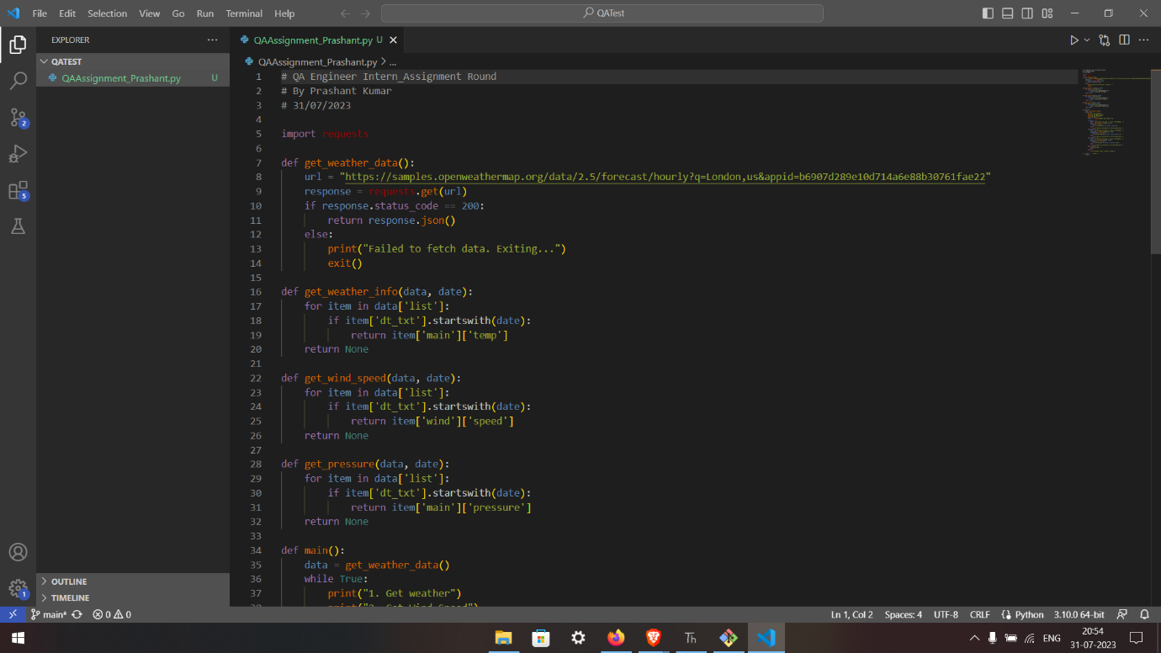

Get Weather 🡪

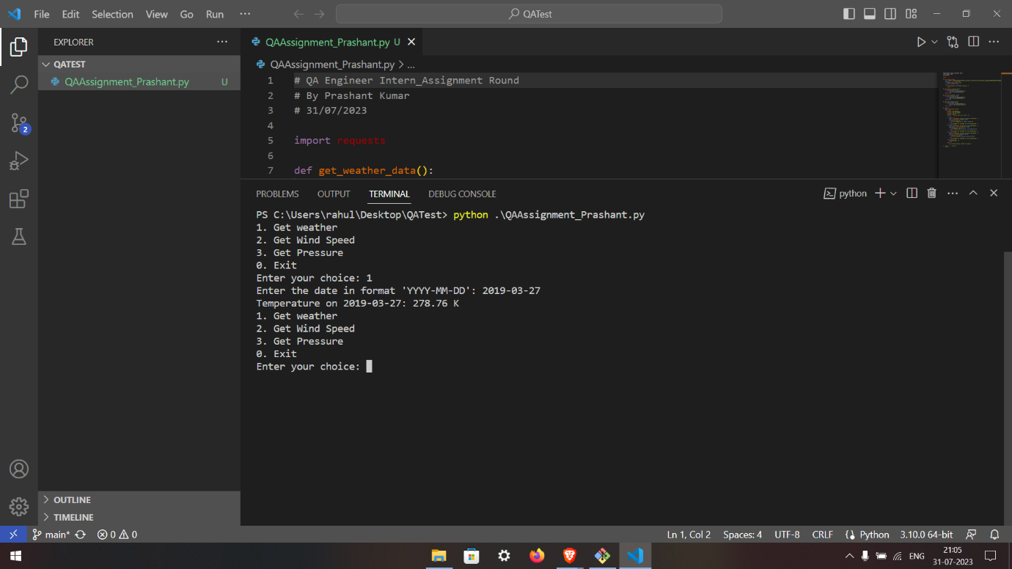

Get Wind Speed 🡪

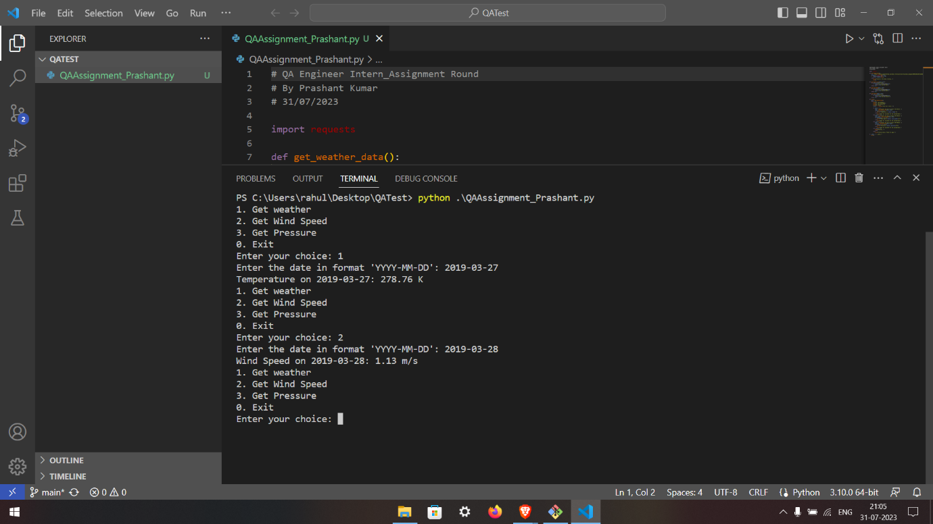

Get Pressure 🡪

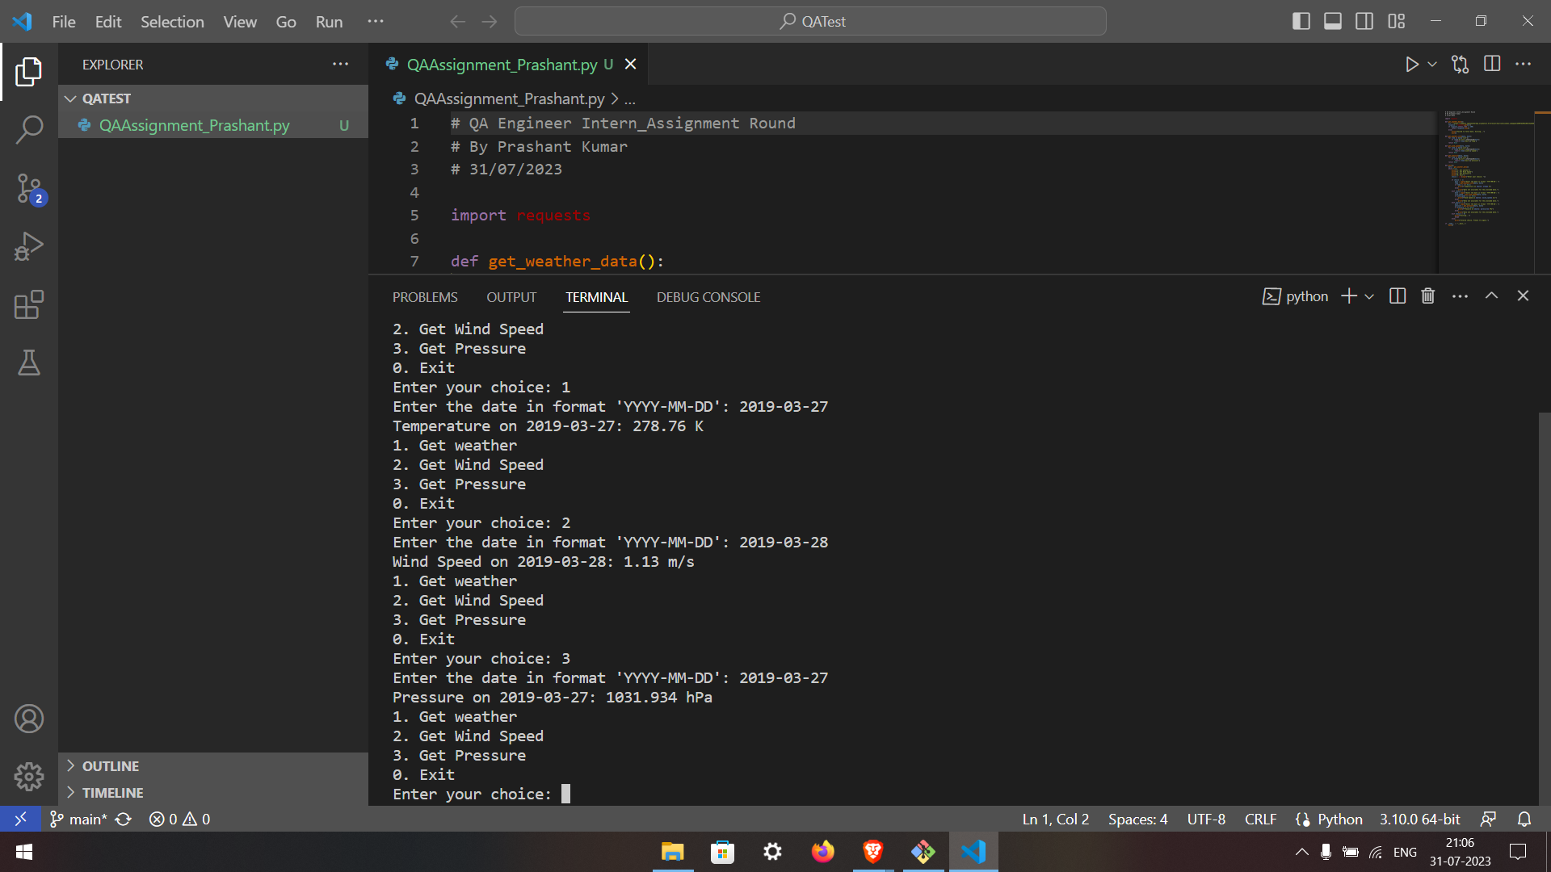

Exit 🡪

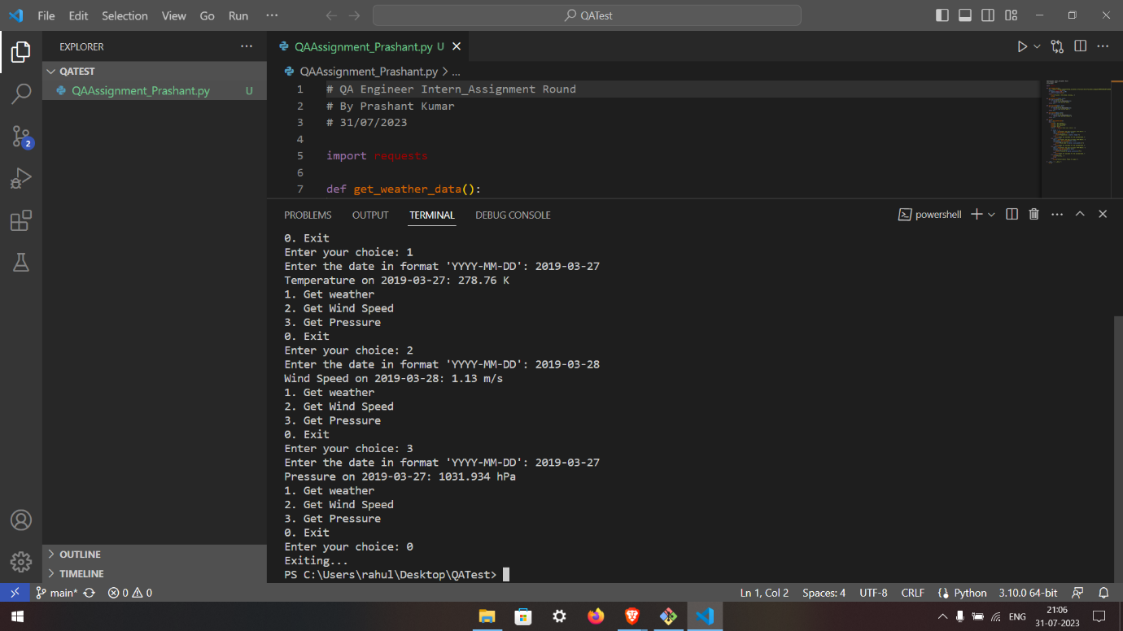

Pushing To Github Repo 🡪

